
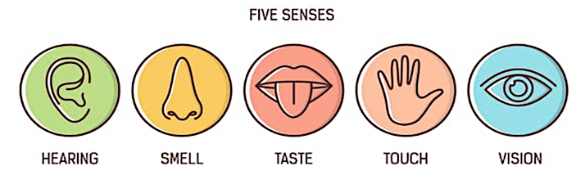
Use your 5 senses to describe the picture below. Use it to write a paragraph in your homework book.
Hear:_______________________________________________________________________________________________________________________________________________________________________________________________________________________________________________________________________________________________
Smell:_______________________________________________________________________________________________________________________________________________________________________________________________________________________________________________________________________________________________
Taste:_______________________________________________________________________________________________________________________________________________________________________________________________________________________________________________________________________________________________
Touch:______________________________________________________________________________________________________________________________________________________________________________________________________________________________________________________________________________________________
Vision:_______________________________________________________________________________________________________________________________________________________________________________________________________________________________________________________________________________________________

