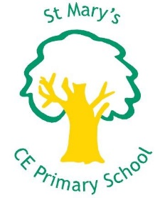
Summer term 2

Sports at St Mary’s
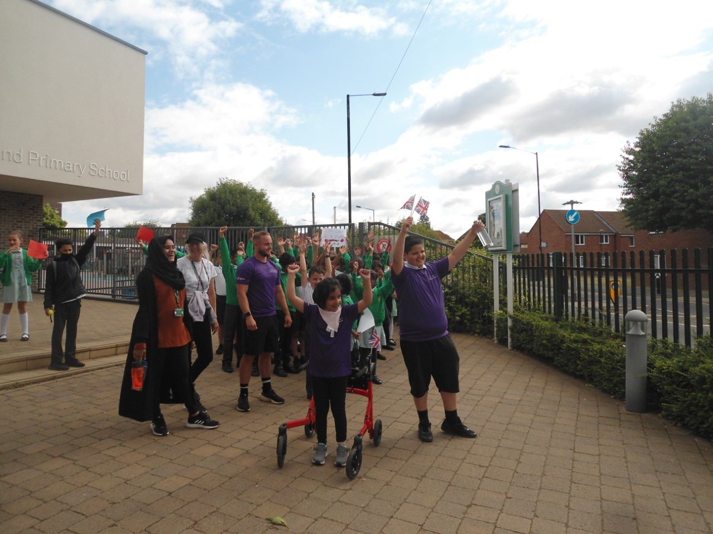
In this issue:
- PE
- Sports events round up
- Sports day
- After School Clubs
- Interschool Tournaments
- Sports Celebration Ceremony

PE

This half term in PE the children practiced two topics, at the start of the half term the children practiced their athletics skills in preparation for sports day. Post sports day the focus switched to Rounder’s for KS2. The weather has been kind resulting in lots of outdoor sunny Rounder’s sessions. The children who were new to the sport have learnt the rules and how the scoring system works. Lots of children have also been able to utilize the many rules and incorporate them into their game plans and tactics. A simplified model of Rounder’s has been used for year Three and KS1. Introducing a more inclusive scoring system the children thrived as they all were able to score points for their team.
Sports events

Relay Baton-
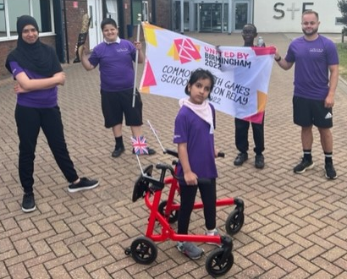
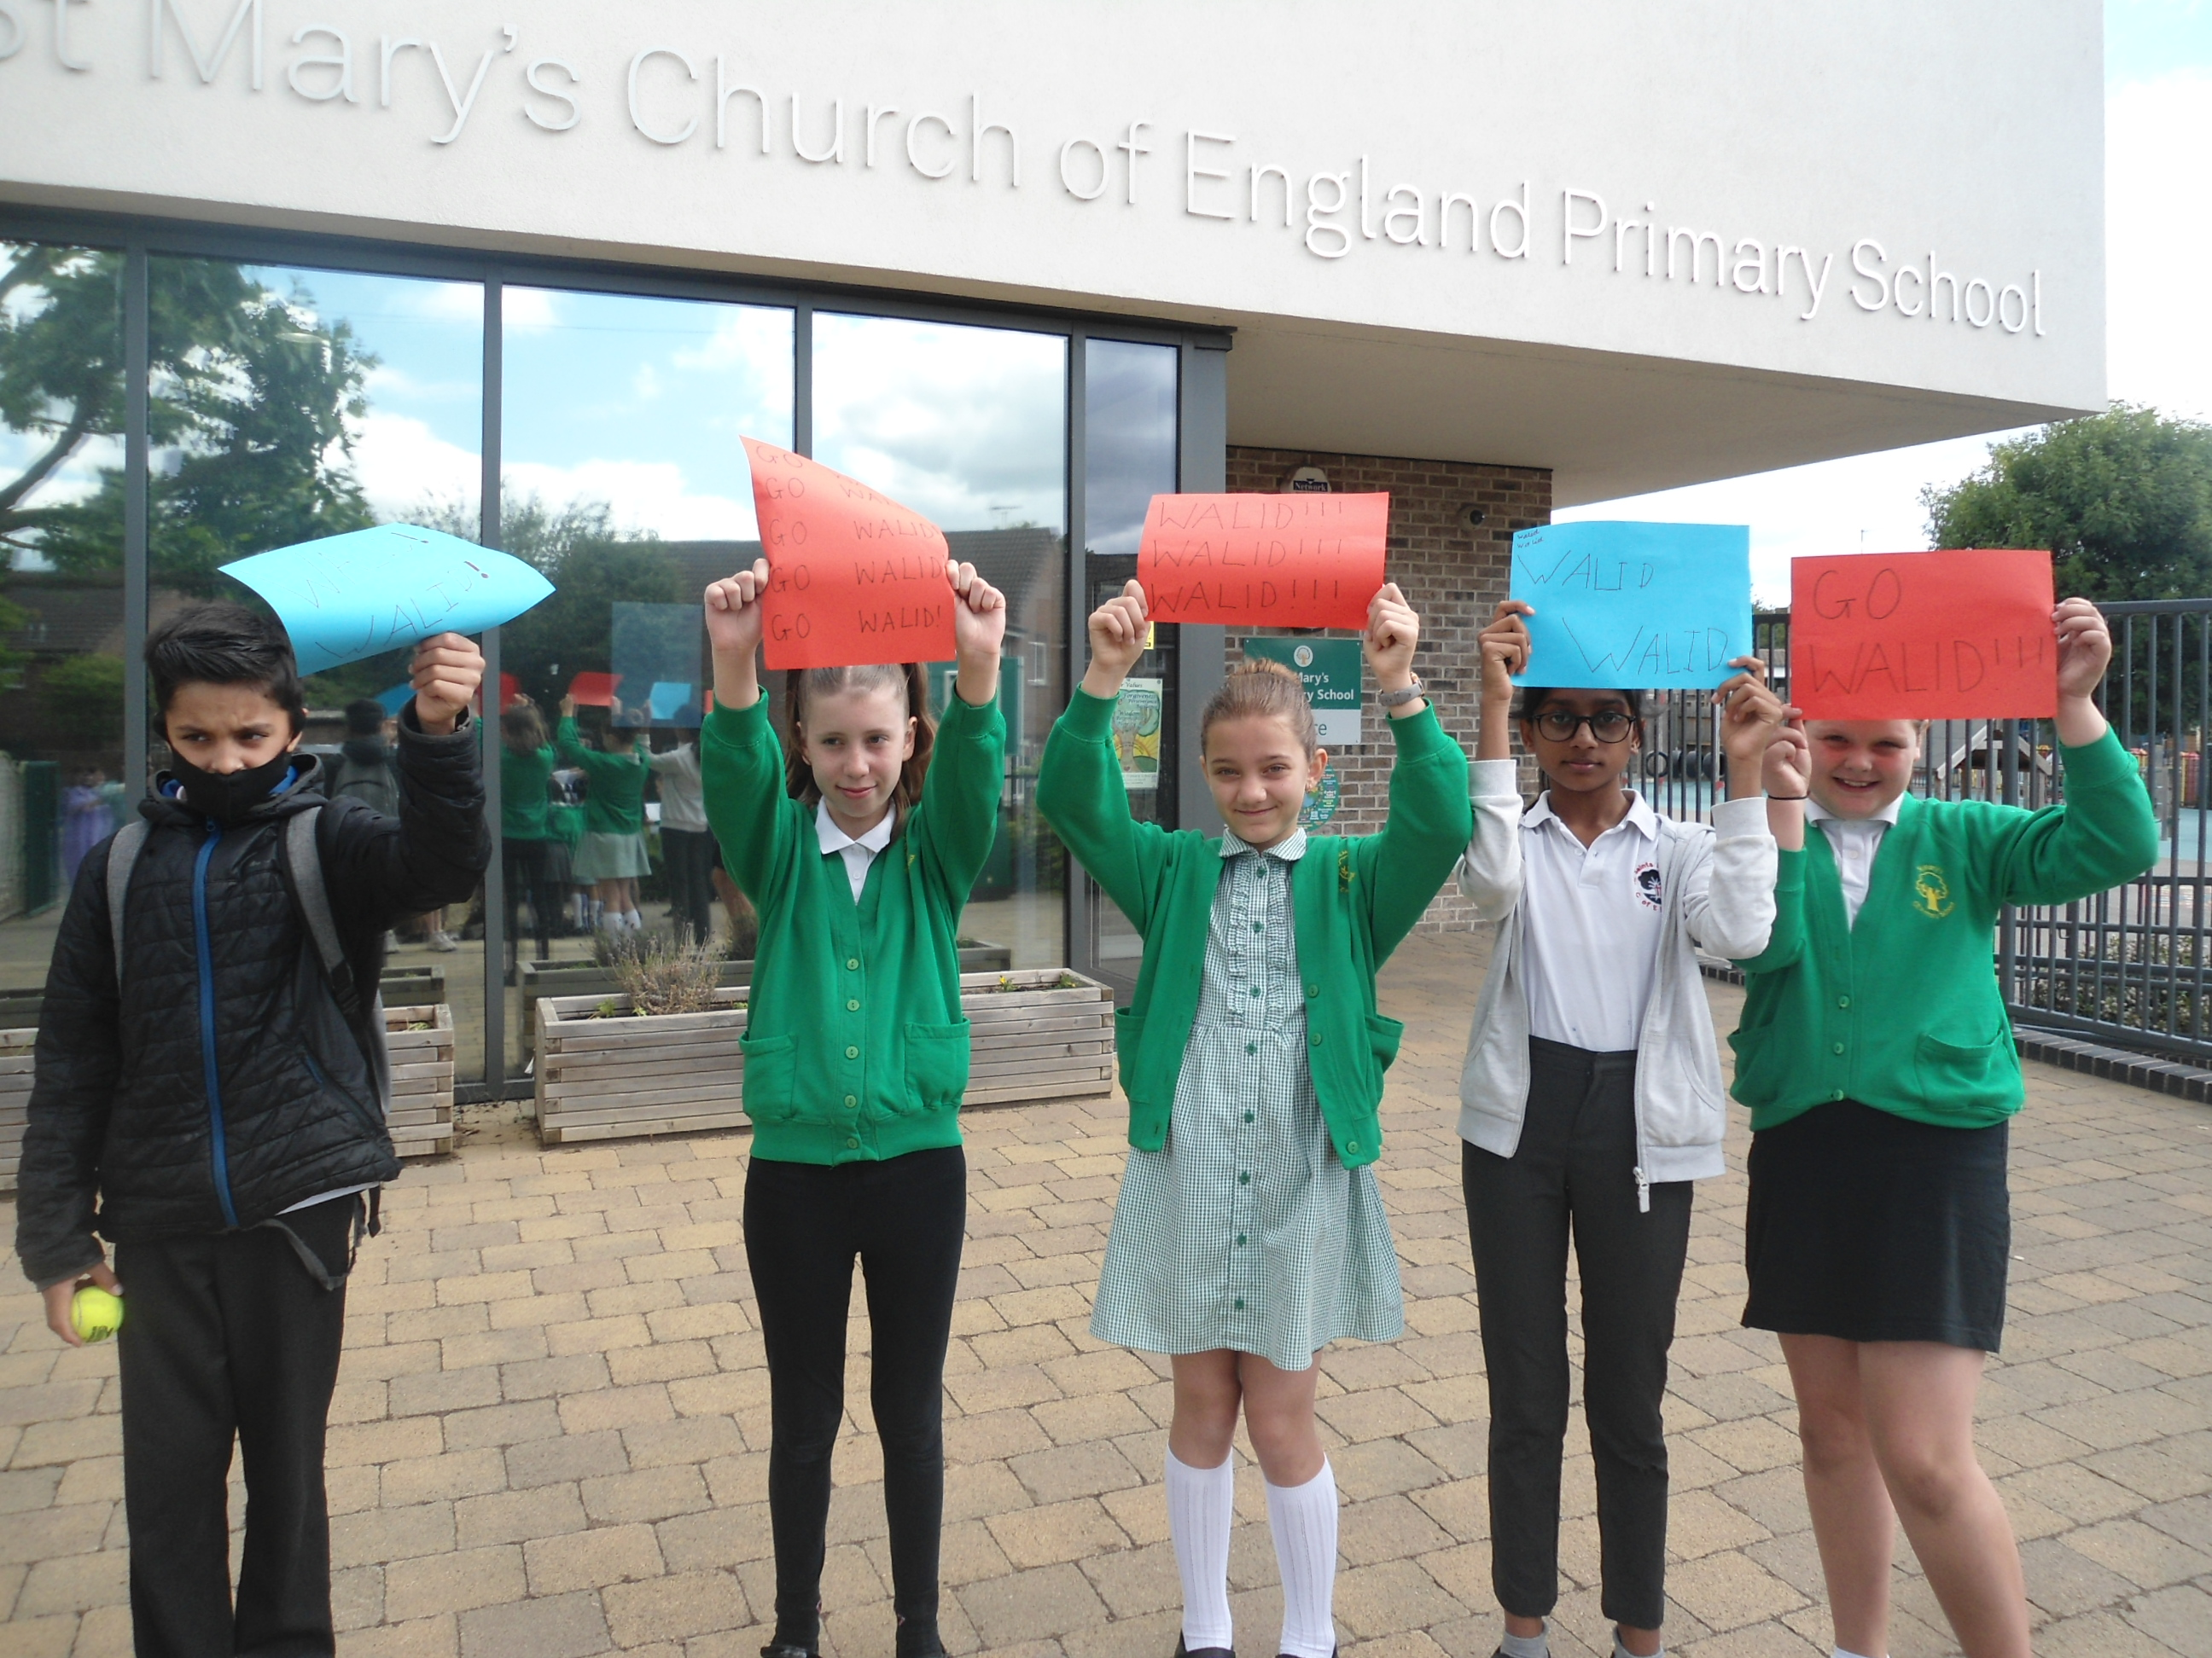On the 5th of July we participated in an event which consisted of every school in slough taking a turn in completing a leg of a relay race. Each school had a set route with ours being from our school to Slough and Eton 1.1 miles long. We received the baton from Long Close to start our journey. Setting a fast pace our two athlete showed determination and resilience to complete their journey. 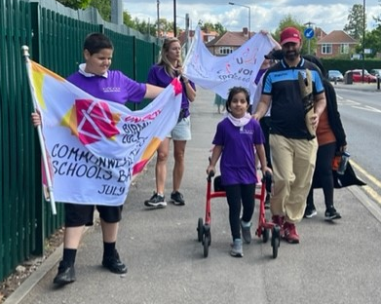
We met new friends along the way in the shape of ex professional footballer and company owner Craig Hodge who has kindly offered to make some donations and will be in touch in the near future. Thank you for such kind words and motivation Craig.
We arrived at Slough and Eton to a warm reception from the SEND students which included two of our former pupil, so nice to see them again and see them growing away from St Mary’s.
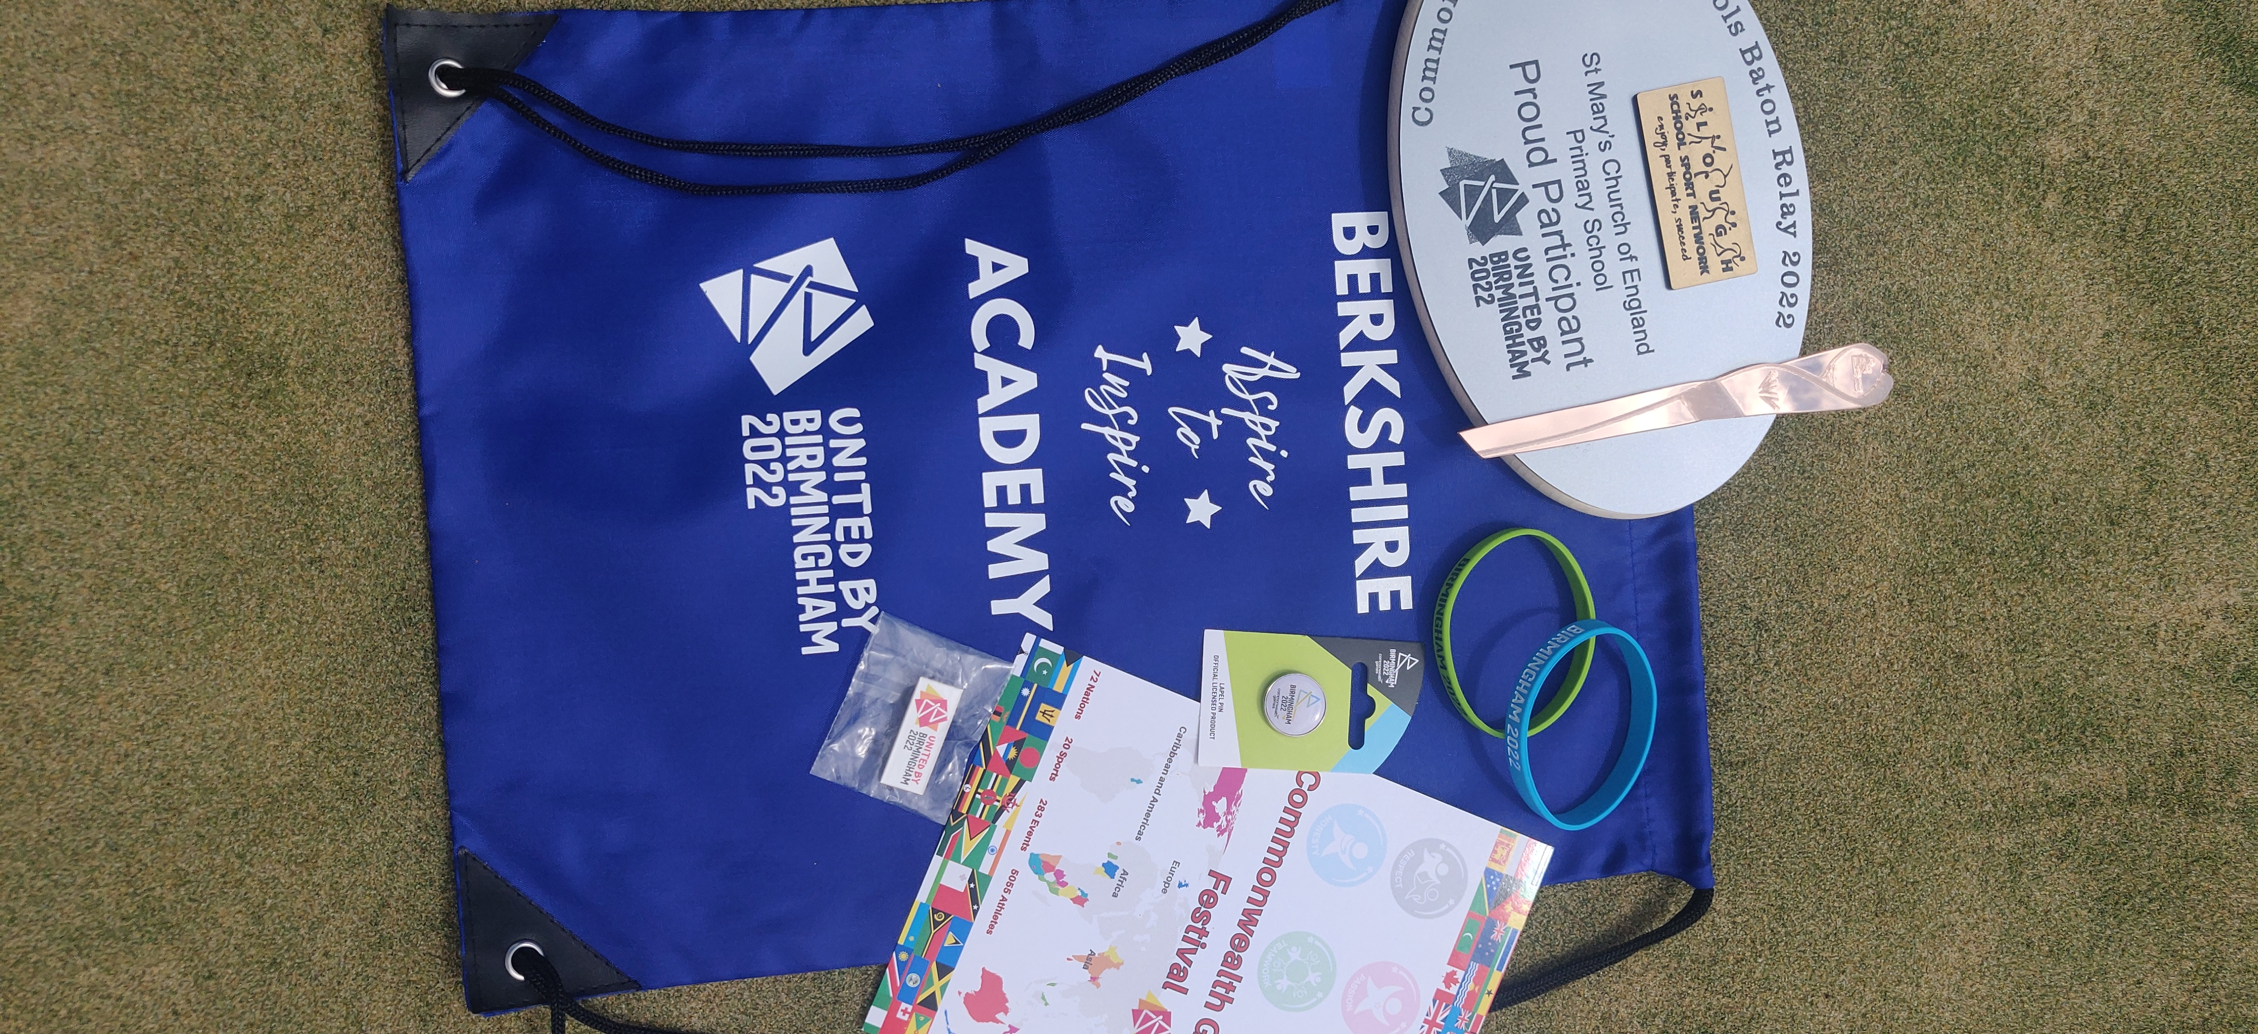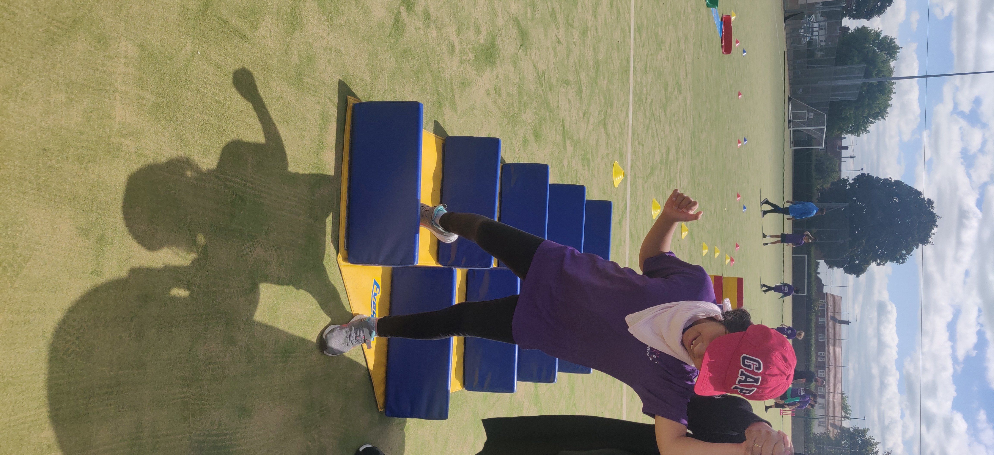The closing ceremony consisted of the two athletes taking part in some more fun activities before the awards were presented. The two athletes received a lovely plague and other goodies to commemorate their success and achievement participating in the baton relay.

Berkshire school games-
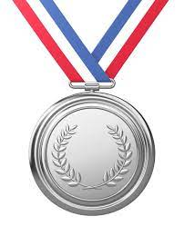
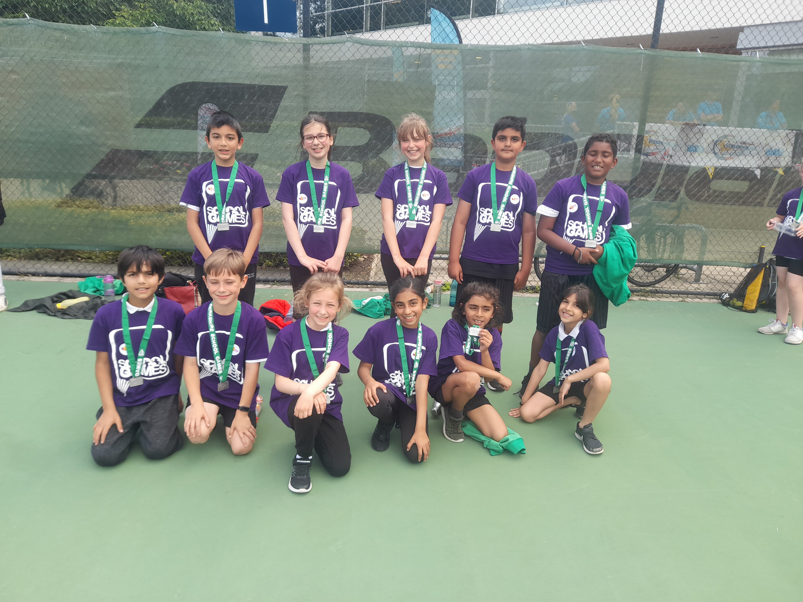On the 1st of July twelve children from year 4 attended an invitation only event held at Bisham Abbey the nation sports center in Marlow. The children were treated to an amazing experience of seeing a nation sports center and all that it offers. The diverse facilities and resources show how sports can offer so much more opportunities than they may have realized. Seeing the national team hockey pitch is a personal favourite of Mr. Bignell’s. The children were specially selected to represent slough in the cricket section of the competition. He children competed in multi cricket skilled based games and activities against other school from other areas such as Reading and more. The behaviour and sportsmanship of the group was a key factor in the judging of the competition, showing great sportsmanship and manor was a real strong point for St Mary’s. Out of the twelve teams featuring in the cricket skills St Mary’s placed second taking home the silver medal. Well Done St Mary’s for making the school proud.

Sports Day
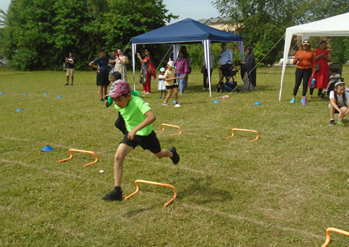

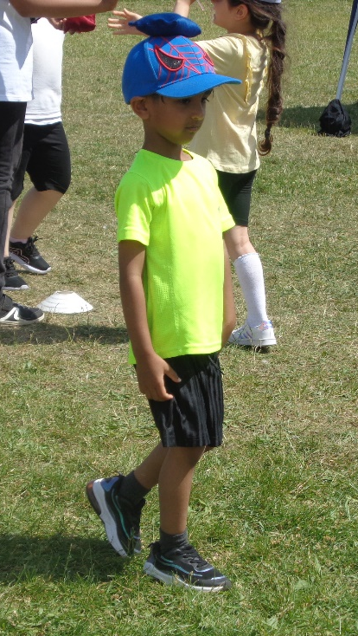
This year the school completed sports day of the course of a week with every phase group having their own time slot. Each year group was put into six team, representing six famous British athletes the children competed in both field and track event to gain points for their team. Each team was assigned a colour with the children urged to wear said colour on sports day. The events were enjoyable and competitive. Every child was active and contributed to their team score. WELL DONE to the WHITE team! Who came out victorious for the week representing famous athlete Jessica Ennis. Score board below, well done to everyone who participated and a big pat on the back to the parents and teachers who also took the opportunity to race in the parents or teacher races. Thank you to all the year six helpers you were amazing!
Jessica Eniss (White) | 2749
Mo Farah (Blue) | 2214
Johnathan Rea (Green) | 1917
Anthony Joshua (Red) | 1880
Ellie Simmonds (Black) | 1835
Chris Hoy (Yellow) | 1667

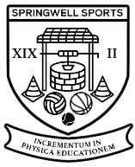
After School Clubs

Springwell Sports after School Clubs-
Mondays- Year 1, 2 &3 Multi Sports, during this club the children practiced new skills and took part in competitive games for sports such as Football, Dodgeball, Cricket and Rounder’s.
Tuesday- 1, 2 & 3 Dodgeball club- the ever so popular dodgeball club was open again to the KS1 children, having lots of fun which practicing their throwing and catching skills.
Wednesday- 4, 5 &6 Dodgeball club- The KS2 version of dodgeball is where the tactics start to come into play, whilst being very competitive the children really show their maturity when making important decisions on the court.
Thursday- Football club- Open to all years from 1-6 this football experience has allowed the children lots of playing time against competitors of their own age. Years 3-6 regularly compete in mini sided tournaments to find a weekly champion.
CONGRATULATIONS to all the player of the week winners for this half term, enjoy the medals.

Tuesday Netball and Basketball club- During our Netball and basketball sessions held on Tuesdays the children have been learning lots of useful skills. Skills such as bouncing the basketball, throwing, passing and catching the netball are just some. The children are enjoying it and we hope to see them thrive into netball stars next year.
Thursday Multi-Sports- For the last half term the in year 1-2 have been given the opportunity to learn in a multi-skills session every Thursday. Run by our external coach George for the Slough School Sports Network, the children have been treated to lots of basic skills required to grow. Using fun inclusive activities the children have thrived and enjoyed themselves.
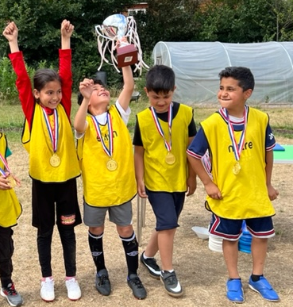
Inter School Tournaments
KS1 Football World Cup
On the 24th of June children from years one & two competed in a world cup format football tournament to celebrate all their skills they have been showcasing throughout the year in PE and football clubs. The tournament had over thirty children competing to help their team to the first ever KS1 football world cup. Each team was given a colour and a country to represent. We saw some future stars take the field who may just be representing their nation as adults in the near future. Each team played four games in a group stage with the ranking setting up the knockout stages. The final featured England (Red) vs Brazil (Yellow), after a very closely contested final the Yellow team (Brazil) came out victorious with a 1-0 win. CONGRATULATIONS! Every child received a participation medal with the winners receiving a special first place medal. Well done to everyone involved and a massive thank you to Mr. Plumley and year 5/6 leaders for assisting Mr. Bignell on the day.

Rounder’s
On the 1st of July our amazing rounder’s team took to the field for the final time to compete against each other in an interschool friendly. The two teams closed out a successful unbeaten season in fashion showcasing their skills one last time in a very competitive fun experience. Well done for such a successful campaign Rounder’s.
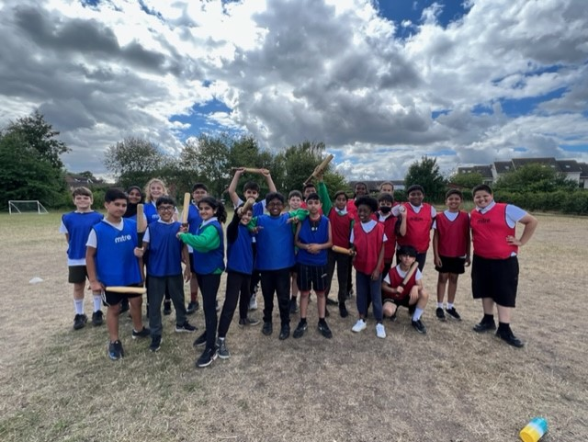

End of Year Sports Celebration Ceremony
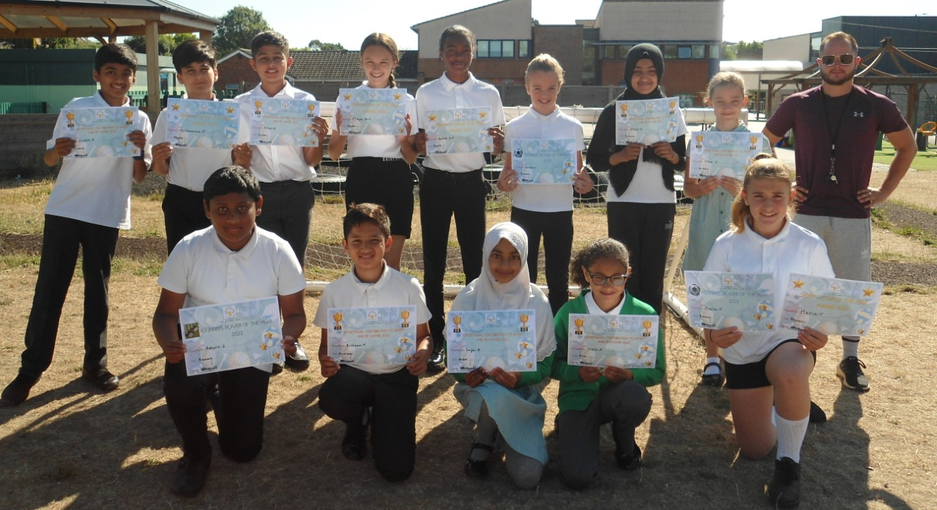
For the first time at St Mary’s we have hosted a sports awards ceremony. Mr. Bignell has chosen a child from every class from years 1-6 to receive a contribution to PE/Sports lessons certificate. Each child won their certificate for different reasons from being kind and helpful, to being an inspiration and role model to other athletes. Below you can see a picture of the year 5&6 winners. Other awards were given out for sport specific player of the season, teams such as the netball team, football teams and rounder’s team were the focus points of this academic year and to celebrate one player was given a certificate. Players who contributed in various ways such as being a leader, being a great athlete or even showing great commitment to improve were some of the criteria used to award these children. Well done to everyone involved in sports teams this year it’s been a pleasure. Looking forward to next year when we start again on this increasingly positive journey we are taking here at St Mary’s in the sports department.

