Autumn term 1

Sports at St Mary’s

In this issue:
- PE
- Events round up

PE

During Autumn 1 the children have been learning football skills during their outdoor PE slot. KS2 have practiced an array of technical skills such as controlling the ball, dribbling, passing and shooting. Towards the end of the half term the children progressed onto more tactical skills such as positioning, attacking and defending. We are hoping the skills can be transferred to our school football teams going forward for the rest of the season. We have had a great uptake in the football teams with places having to be limited.
KS1 have also been practicing their football skills, using a more basic approach the children have also been learning the basics of football with skills such as controlling the ball, dribbling, passing and even some accuracy shooting. The children have learnt some new games which they have enjoyed so much they have been practicing at break times thanks to the new netball court markings on the playground.
Next half term the children will move onto netball and basketball skills.
We will be welcoming reception to their first PE lessons which is very exciting.
Sports events
Year 3 Cricket Skills-
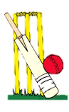
On the 14th of September a selection of keen cricketers from year three attended a cricket festival at Slough Cricket club. The group spent the afternoon learning and practicing cricket skills from some specialized cricket coaching. The children played and competed against other schools in mini adapted cricket games. The children really enjoyed themselves and have now found a new sport they are excited to play come summer term. As well as memories the child were gifted some medals and certificates to commemorated their efforts on the day.

Year 3/4 Boys Football-
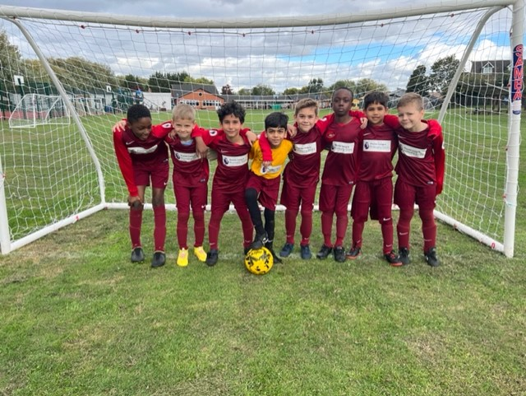This half term the year 3/4 Boys football team featured in two fixtures. The boys played against Langley Heritage and Montem Academy. Unfortunately the results did not go the way of St Mary’s but the boys have enjoyed themselves and have learnt a lot in the process. Back to the training ground we go to continue the development of these young keen footballers.

Year 5/6 Boys Football-
14th October, the year 5/6 Boys football team played in a football fixture vs Cippenham @Cippenham. The match unfortunately didn’t go the way of St Mary’s but we gained some valuable experience. Boys showed desire and heart to battle out a closely fought match. The team return to the training field to work on their positioning ready for the 19th October.
19th October, the year 5/6 Boys football team took 15 players across the road to Lascelles Park to compete in a double match vs Long Close. Mr. Bradley took the red team whilst Mr. Bignell took the green team. Both matches turned out to be huge successes with the Green team winning their match 7-2 and the Red team winning 7-0. Huge congratulations to the year 5/6 boy’s football teams who showed great sportsmanship, team work and understand of football tactics. A special well done to the boys who competed the week before who have shown such great resilience after their defeat against Cippenham.


