
Spring Term 2
PE and Sports at St Mary’s
In this issue:
- PE
- Sports fixtures
- Clubs

PE
This term in PE St Mary’s staff have continued to deliver the Real PE Curriculum.
We have also added a new curriculum called ValSabin.
ValSabin focuses more on sports and athletics which gives our school a broader range of skills for the children to develop and grow with.
Creative was our learning behaviour theme this half term.
This is seen as the purple cog on our Real PE Wheel.
Year Group | Outdoor PE focus  ValSabin | Indoor PE focus Real PE | Learning Focus and Targets: Cognitive
Reception |  | In this unit, the children have developed and applied their ball skills and counterbalance with a partner through focused thematic stories, songs, and games. | Expected- I can observe and copy others.  Exceeding- I can explore different movements.  I can explore and describe different movements.
Year 1 | Children have learnt:  Demonstrate co-ordination when passing a ball around different parts of the body.  Bounce and pat-bounce a ball with a degree of control.  Understand how to send, receive, kick, and dribble a ball and practice to improve the skills.  Show a degree of control when sending and receiving a range of equipment.  Understand that they must “get in line with a ball to receive it.”  Send a ball in various ways to play individual target games or target games with a partner. | In this unit, children have developed and applied their ball skills and counterbalance with a partner through focused skill development sessions, thematic stories, and games. | Emerging- I can observe and copy others.  Expected- I can explore and describe different movements.  Exceeding- I can select and link movements together to fit a theme.  I can begin to compare my movements and skills with those of others.
Year 2 | Children have learnt:  Demonstrate consistency and accuracy in bouncing, kicking, throwing, catching, and striking skills.  Select appropriate equipment when playing the games and demonstrate quicker passing and receiving skills.  Play with confidence in varying group formations.  Invent rules and explain how they can improve the game.  Understand and use simple tactics to work as a team. | In this unit, children have developed and applied their ball skills and counterbalance with a partner through focused skill development sessions, cooperative and competitive games. | Emerging- I can explore and describe different movements.  Expected- I can begin to compare my movements and skills with those of others.  I can select and link movements together to fit a theme.  Exceeding- I can respond differently to a variety of tasks or music.  I can make up my own rules and versions of activities.
Year 3 | Children have learnt:  Accurately pass and receive a range of balls in different ways.  Demonstrate control when dribbling, passing, and receiving.  Signal for the ball and pass and receive in sequential order.  Pass and receive on the move and signal for the ball to retain possession.  Play with confidence in various small game formations. | In this unit, the children have learnt, developed, and applied their sending, receiving and counterbalance with a partner through focused skill development sessions, healthy competition, cooperative games, and Personal Best challenges. | Emerging- I can begin to compare my movements and skill with those of others.  I can select and link movements together to fit a theme.  Expected- I can make up my own rules and versions of activities.  I can respond differently to a variety of tasks.  Exceeding- I can change tactics, rules, or tasks to make activities more fun or more challenging.  I can link actions and develop sequences of movements that express my own ideas.
Year 4 | Children have learnt:  Play confidently in small-sided invasion games using various formations.  Use a range of techniques to pass and travel with the ball.  Use a range of tactics to keep possession of the ball and get into position to shoot and score.  Understand how to dodge, mark, signal for the ball and intercept.  Play within the rules.  Recognise aspects that need improving. | In this unit, the children have learnt, developed, and applied their sending and receiving and counterbalance with a partner through focused skill development sessions, healthy competition, cooperative games, and group Personal Best challenges. | Emerging- I can begin to compare my movements and skills with those of others.  I can select and link movements together to fit a theme.  Expected- I can make up my own rules and versions of activities.  I can recognize similarities and differences in movements and expressions.  Exceeding- I can link actions and develop sequences of movements that express my own ideas.  I can change tactics, rules or tasks to make activities more fun or more challenging.
Year 5 | Children have learnt:  Choose and use skills which meet the specific needs of ball handing invasion games.  Understand and show how a team can retain possession and find ways of progressing towards an opponent’s goal.  Demonstrate a range of skills, using one hand or two, for passing and receiving; carry, bounce and dribble a ball in a controlled manor.  Find and use space to help their team and use a variety of tactics to keep the ball. | In this unit, the children have learnt, developed, and applied their seated balance and floor work balance through focused skill development sessions, modified/non-traditional games and sports and healthy competition. | Emerging- I can make up my own rules and versions of activities.  I can recognize similarities and differences in movements and expression.  Expected- I can link actions and develop sequences of movements that express my own ideas.  I can change tactics, rules or tasks to make activities more fun or more challenging.  Exceeding- I can respond imaginatively to different situations.  I can adapt and adjust my skills, movements or tactics so they are different to others.
Year 6 | Children have learnt:  Understand and demonstrate a range of controlled passing, receiving, dribbling, and shooting skills when playing ball handling games.  Play a range of small-sided games and make effective choices about when, how, and where to pass.  Know and understand the positions they play and identify and show specific attacking and defending skills.  Understand how to organize their own team into different formations to concentrate more on attack or defense. | In this unit, the children have learnt, developed, and applied their seated balance and floor work balance through focused skill development sessions, modified/ non-traditional games and sports and healthy competition. | Emerging- I make up my own rules and versions of activities.  I can respond differently to a variety of tasks or music.  Expected- I can change tactics, rules, or tasks to make activities more fun or challenging.  I can respond imaginatively to different situations.  I can adapt and adjust my skills, movements or tactics so they are different to others.
Sports Fixtures

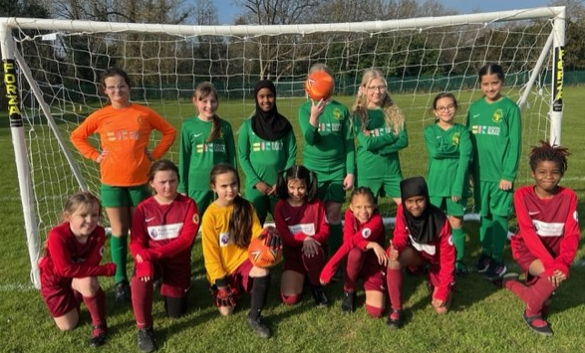
8th March - Two girls football teams represented St Mary’s away at Penn Wood. We took a mixed team of year 3&4 girls and a team of year 5&6 girls.
Both games were extremely exciting and competitive. The year 3&4 girls’ team unfortunately came out the wrong side of a 7-6 thriller. So many goals scored by both teams made for a very fun and competitive match.
The year 5&6 girls were playing at the same time on the other football pitch. They ran out comfortable winners’, winning their match 7-0. Well done to both girls’ teams on International Women’s Day!

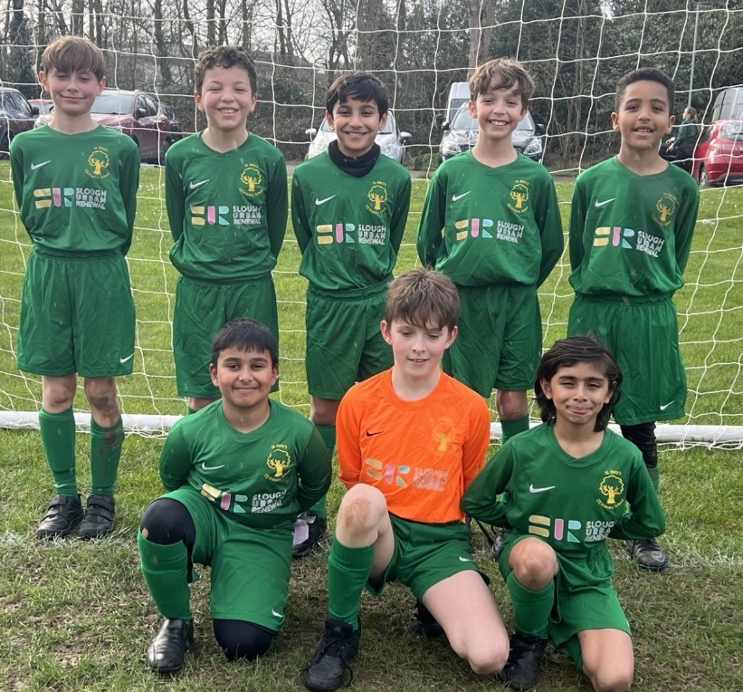
15th of March - We rounded off a complete series of fixtures against our friends at Penn Wood Primary School. The boys 5&6 football team took part in an exciting 7-5 win. We started out slow, going down 4-1 by half time. The boys showed resilience and determination to fight back and finish on top. With lots of exhilarating moments, including a penalty save from our goalkeeper, the match was a great spectacle!
Well done boys!

Clubs
Dodgeball Clubs: This half term the ever-popular Dodgeball Club ran as usual. Two days a week – a session for KS1 and one for KS2. During these sessions children engage in the safe, fun and competitive game of dodgeball in an enjoyable and inclusive environment with the added element of pop music.
Multi Sports Club: This half term we offered Multi Sports on Mondays and Thursdays for KS1 and KS2 respectively. During our KS1 Monday sessions, the children learnt and played dodgeball, badminton, cricket, Boccia, curling, and Speed Stacks. During our Thursday KS2 sessions, the children took part in dodgeball, badminton, cricket, and rounders.
Football club: This half term we have brought back football club for KS2 students. Due to the field being out of use, sessions have consisted of mostly skill work. Skills such as dribbling and tacking have been major focuses, using fun inclusive games to develop skills to retain possession.
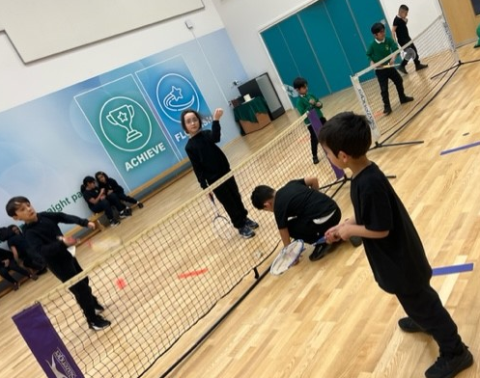
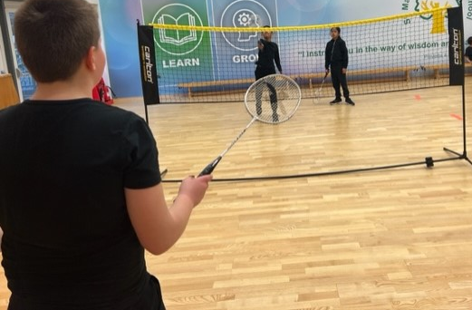
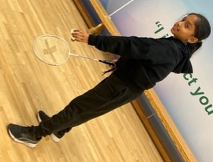
Yoga Club: This half term Mrs. Sabat continued to teach her Yoga club for Years 3 & 4 pupils. Using a variety of themes such as Superhero Yoga, Ocean Yoga and Gratitude, the children have been benefitting from: improved focus, memory, self-esteem, academic performance, and positive classroom behaviour. Yoga can help to reduce anxiety and stress in children and can help provide calmness and clarity. It can also improve social behaviour and physical skills such as balance, strength, and flexibility.

