Spring Term 1
PE and Sports at St Mary’s
In this issue:
- PE
- Sports fixtures
- Sports trips
- Clubs
PE
This term in PE St Mary’s staff have continued to deliver the Real PE and Real Gymnastics Curriculum during outdoor and indoor PE lessons. Below shows the skills the children have been working extremely hard with to develop their Physical Education.
Cognitive was our learning behaviour theme this half term. This is seen as the yellow cog on our Real PE Wheel.
Year Group | Outdoor PE focus | Indoor PE focus Gymnastics | Learning Focus and Targets: Cognitive
Reception | In this unit, the children have developed and applied their dynamic balance on a line and stance through focused and thematic stories, songs, and games. |  | Expected- I can follow simple instructions.  Exceeding- I can understand and follow simple rules. I can name some things I am good at.
Year 1 | In this unit, children have developed and applied their dynamic balance on a line and stance through focused skill development sessions, thematic stories and games. | In this unit, children have learnt, developed, and applied flight and rotation on the floor and with apparatus. Year one has also used thematic warm-ups and games to further aide their development. | Emerging- I can follow simple instructions.  Expected- I can name some things I am good at.  Exceeding- I can begin to order instructions, movements, and skills.
Year 2 | In this unit, the children have developed and applied their dynamic balance on a line and stance through focused skills development sessions, cooperative and competitive games. | In this unit, children have learnt, developed, and applied flight and rotation on the floor and with apparatus. Year one has also used thematic warm-ups and games to further aide their development. | Emerging- I can name some things I am good at.  Expected- I can recognize similarities and differences in performances.  Exceeding- I can explain what I am doing well, and I have begun to identify areas of improvement.
Year 3 | In this unit, the children have developed and applied their dynamic balance on a line and ball skills through focused skill development sessions, healthy competition, cooperative games, and Personal Best challenges. | In this unit, the children have learnt, developed, and applied flight and balance on the floor, on low and large apparatus through focus skill development. | Emerging- with help, I can recognize similarities and difference in performance.  Expected- I can explain what I am doing well, and I have begun to identify area for improvement.  Exceeding- I can understand ways (criteria) to judge performance.
Year 4 | In this unit, the children have developed and applied their dynamic balance on a line and ball skills through focused skills development sessions, healthy competition, cooperative games and group Personal Best challenges. | Year 4 had the special privilege of having an outside Dance teacher from the slough school sports network take charge of their PE lessons. The children have used Hip- Hop themes with engaging music to produce and deliver routines to battle in a competitive and fun environment. | Emerging- With help, I can recognize similarities and differences in performance.  Expected- I can explain what I am doing well, and I have begun to identify areas for improvement.  Exceeding- I can understand ways (criteria) to judge performance.
Year 5 | In this unit, the children have developed and applied their stance and footwork through focused skill development sessions, modified/non-traditional games and sports and healthy competition. | In this unit, the children have learnt, developed, and applied all gym skills on the floor, through partner work and on large apparatus through focused skills development, sequences creation and games. | Emerging- I can perform all trickier challenges (floor.)  Expected- I can perform all Tricker challenges (floor and apparatus.)  Exceeding- I can perform all Trickiest challenges (floor and apparatus.)
Year 6 | In this unit, the children have developed and applied their stance and footwork through focused skill development sessions, modified/non-traditional games and sports and healthy competition. | In this unit, the children have learnt, developed, and applied all gym skills on the floor, through partner work and on large apparatus through focused skills development, sequences creation and games. | Emerging- I can perform all trickier challenges (floor.)  Expected- I can perform all Tricker challenges (floor and apparatus.)  Exceeding- I can perform all Trickiest challenges (floor and apparatus.)
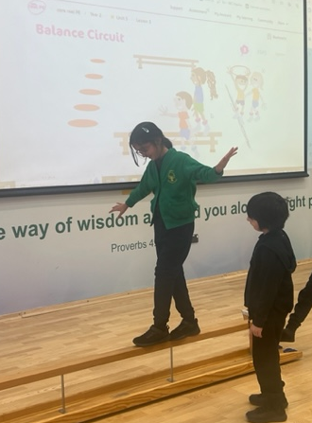
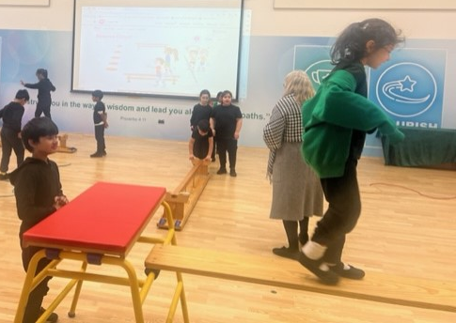

Sports Fixtures
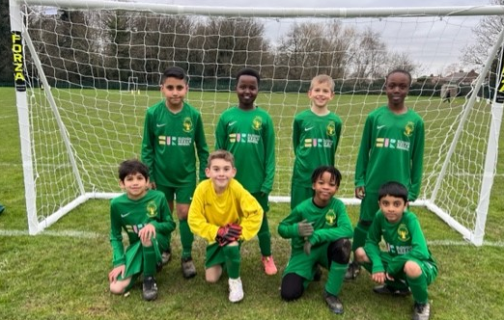
On the 12th of January the boys Year 3&4 football team travelled to Penn Wood to partake in a friendly fixture. The boys ran out a very convincing win with the score being 9-1 to St Mary’s. The boys showed class and sportsmanship - even with such a convincing victory. The boys showed they had an eye for goal with multiple different goal scorers.

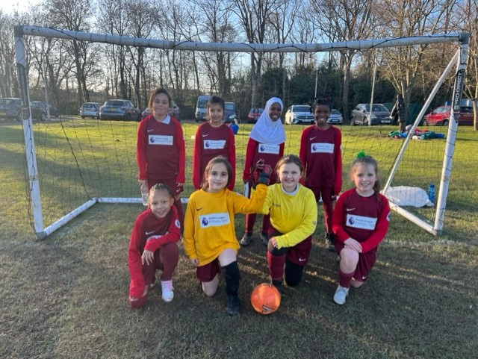
On the 12th of January the girls Year 3&4 football team had their first ever match. They also visited our friends Penn Wood. The game ended 0-0. The girls had lots and lots of chances to score and if it wasn’t for a tremendous goal keeping performance from the opposition, I’m sure they would have scored a hat full. The girls fought until the end but just couldn’t break the deadlock.

Sports Trips
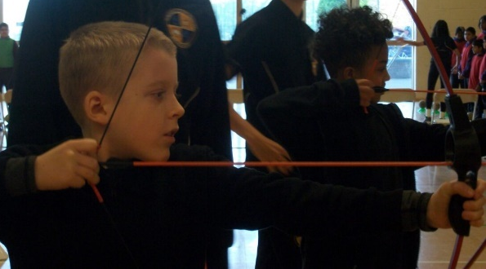
On 16th of January a group of mixed Year 4 students attended the Slough Schools Sports Network event organized and run by the Invictus Games. During this event, St Mary’s met up with other children from the schools of Iqra, Langley Academy, Western House, and James Elliman. The children spent the afternoon participating in and learning new sports and skills such as archery, Dangerball and hockey. The children were given a score out of 30 on four sets of criteria: friendship, respect, determination, and courage. With a possible score of 120 available our children collected a massive total of 117 points. We had some lovely feedback from coaches at the event highlighting how our children were extremely helpful which resulted in lots of Dojos being awarded.
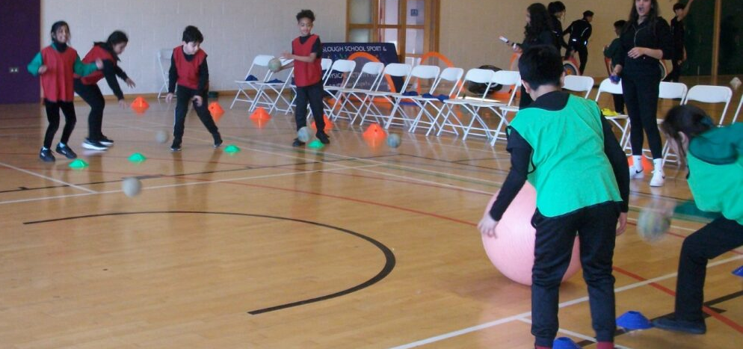
On 7th February As part of the Slough School Sport and Physical Activity Network programme, 12 children from Year 2 attended Singh Sabha Sports Centre, where they learnt new techniques and skills in cricket.
The children represented St. Mary's well demonstrating good listening skills, impeccable behaviour and fantastic teamwork. They expressed how much they thoroughly enjoyed the experience and were overjoyed to receive medals at the end!
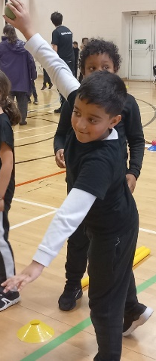
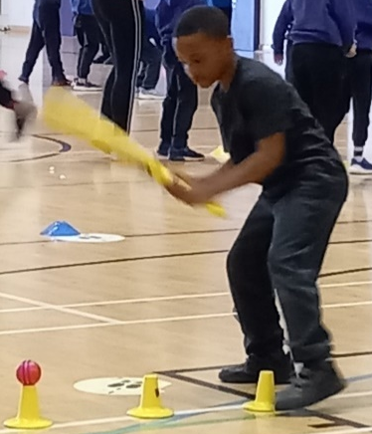
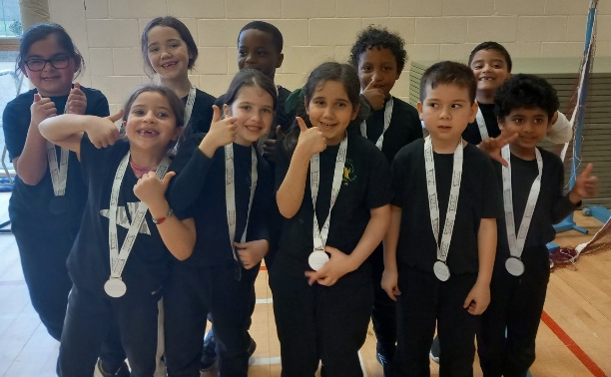

Clubs
Dodgeball Clubs: This half term the ever-popular Dodgeball Club ran as usual. Two days a week - one for KS1 and one for KS2, the children engage in the safe, fun and competitive game of dodgeball in a fun and inclusive environment with the added element of some music.
Multi Sports Clubs: This half term we offered Multi Sports on Mondays and Thursdays for KS1 and KS2 respectively. During our KS1 Monday sessions, the children learnt and played dodgeball, badminton, cricket, Boccia, curling, and Speed Stacks. During our Thursday KS2 sessions, the children took part in dodgeball, badminton, cricket, and rounders.
Dance Club: Our special guest dance instructor from Slough School Sports Network has been running an afterschool club every Thursday with our Year 2 and Year 3 pupils. During these sessions, the children have explored different dance techniques and themes through fun, inclusive and competitive activities including Dance Battles - putting teams in a competitive environment to showcase their new dancing skills.
Yoga Club: This half term Mrs. Sabat started her Yoga club for Years 3 & 4 pupils. Using a variety of themes such as Superhero Yoga, Ocean Yoga and Gratitude, the children have been benefitting from: improved focus, memory, self-esteem, academic performance and classroom behaviour. Yoga can also reduce anxiety and stress in children and can also help provide calmness and clarity, improve social behaviour as well as physical skills such as balance, strength, and flexibility.



