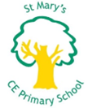
Sports week 2024

During the week of the 17th June, St Mary’s celebrated the up-coming sports week taking place from 24th June by inviting guest speakers from the sporting world to share their experiences with the children. We welcomed a wide range of professionals from different fields of sport.

Everyday over the week we had guests split over assemblies for KS1 and KS2. Each day, two amazing speakers spoke about their professional journey and shared their expertise during the morning assemblies.

On Monday, we welcomed two guests to our KS1 assembly, Bernard Mensah, an ex-professional footballer and Colin Leslie, a local public health youth worker. Bernard shared stories about his journey as an academy graduate at Watford FC to his retirement.
Colin gave us important information about healthy living and dietary needs.


On Monday, during KS2 assembly we met Aaron, a representative from Brentford FC premier league football club community sports trust. Aaron taught us about what he does at Brentford FC and the community around this area. He also gave us great advice on alternative exercise.

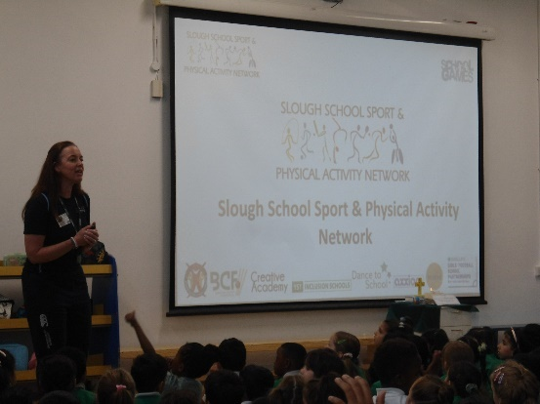
On Tuesday, we were treated to two very special guests from the world of martial arts.
KS1 met two guest speakers in the form of Laura Brookstein, a representative of the Slough School Sports Network (SSSN).
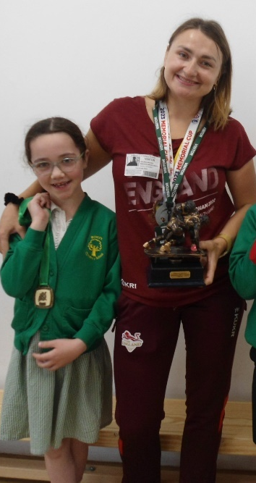
Laura spoke about her role and the opportunity the network offer to all students in Slough. At St Mary’s we work closely with SSSN to help provide opportunities for our children to participate in sporting events on a regular basis.

We also had Aksana, a Paralympian medalist from Ukraine, who spoke about her achievements and showcased her medals. Aksana took pictures with the children; this was a special experience as we all got to see and hold some very exclusive medals.
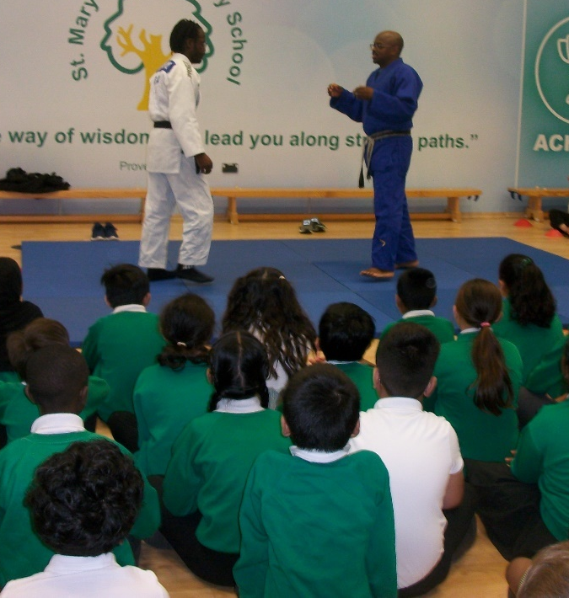
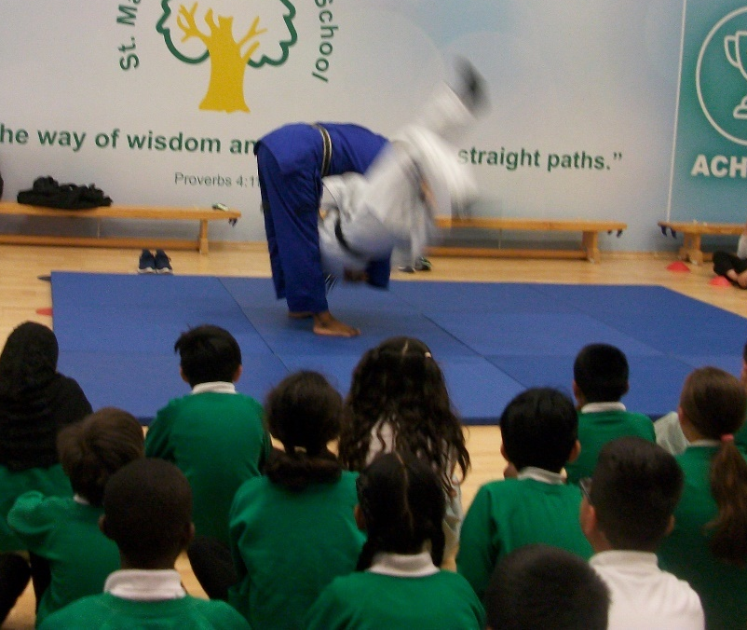
KS2 also had a very special set of guests on Tuesday. We welcomed Basil and his son, who are both black belts in the martial art of judo. They spoke about the discipline and skills required in judo which can be translated to all sports. Basil and his son also showed us some very exciting throws!

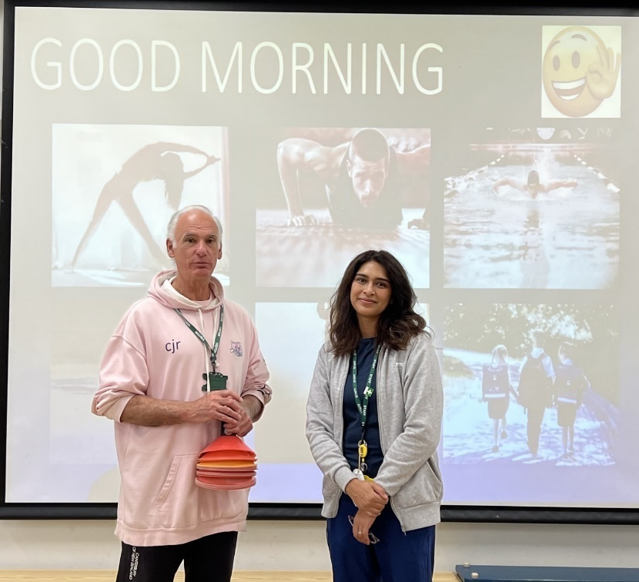
On Wednesday, KS1 met Conrad who runs the local athletics club in Slough. Conrad was very enthusiastic about his work, sharing stories of some of the success his athletes have achieved. Conrad taught us about key skills required for athletics and the importance of health to be a good athlete.

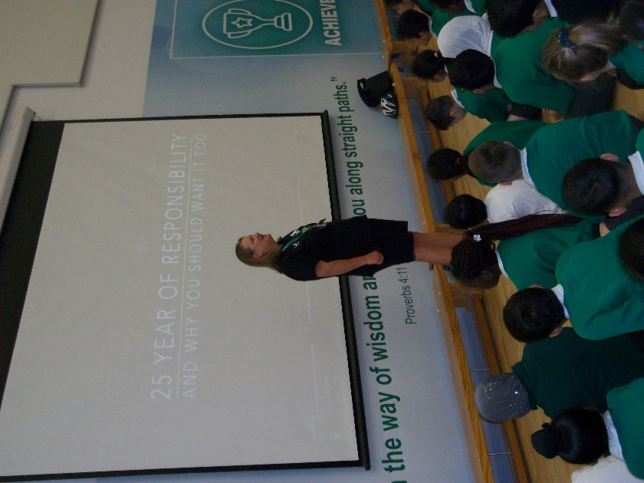
KS2 had the opportunity to meet and hear from Jane Lilly, a PE teacher at Herschel Grammar Secondary School, and one of her year 13 students. Jane shared her experiences and expectations for a secondary school PE department. Jane shared some inspirational thoughts to motivate and excite our students for secondary school life.

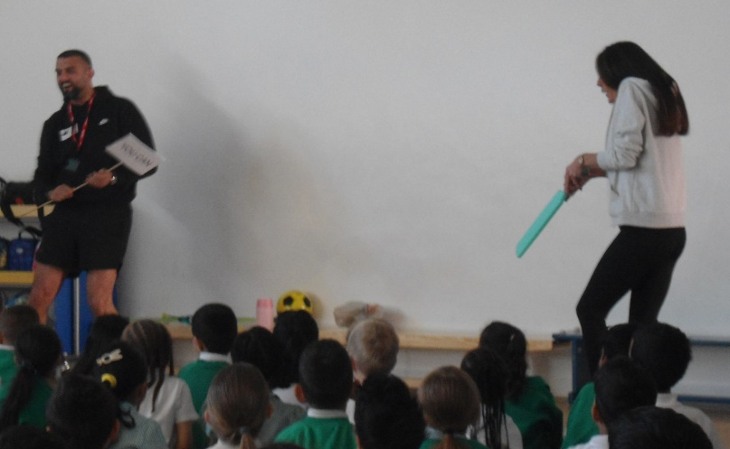
On Thursday, KS1 met Tariq from the Acai Clubs, a well-established local running group and business owner. Tariq was extremely energetic and motivated the children by playing games with his catch phrase ‘You can’.

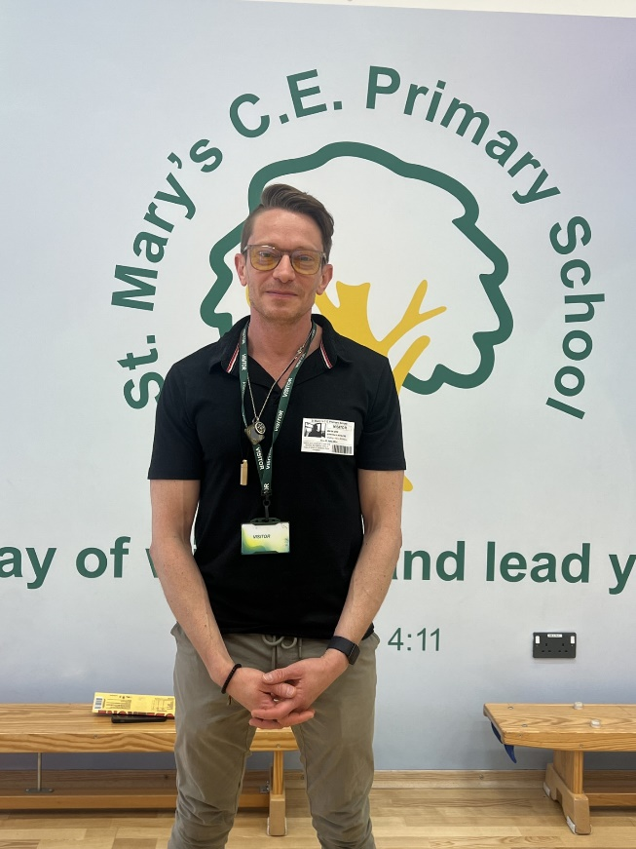
KS2 met Marktheevrydayathlete. Mark shared stories about his life as a child and the hurdles he had to overcome with his health.
Mark gave us amazing insight into the importance of nutrition, motivation and never giving up. Mark left us with a great quote ‘If you want to run fast, run alone. If you want to run far, run as a team’.

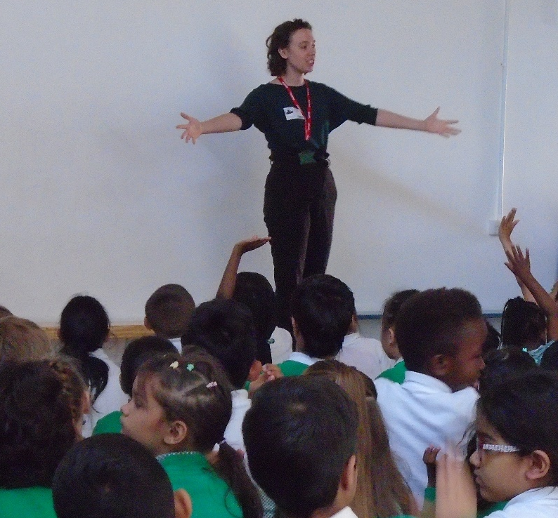
For our final day of guest speakers, on Friday KS1 met Lucy a local dancer. She showed some dance moves and gave the children a chance to join in with some dances. She showed the children how exercise can be fun and not just competitive with sports.

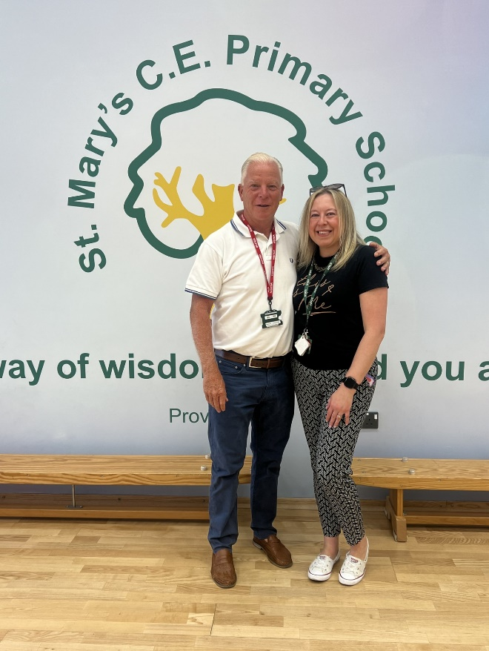
Meanwhile, KS2 met Gordon Bartlett. Gordon is a retired professional footballer, football manager and an ex-PE teacher. During Gordon’s speech, he educated the children about how his setbacks and failures motivated him to succeed. He explained that he had to retire as a football player at a young age, but then went into coaching. By the age of 33, he was managing a football team playing at Wembley in a cup final!

Thank you to all our wonderful guest speakers!
You have given the children valuable insight and have motivated our future stars!

