Recommended reading list for year 2023-2024
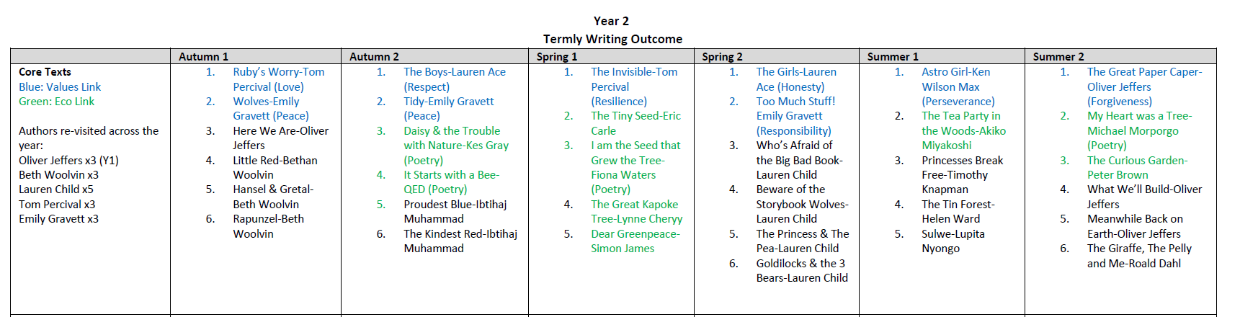

These are the reading books we will be covering in our English and Guidied Reading Units so please feel free to look and become familiar with the range of texts that will we be covering.

