Homework- 13th December 2024.
Due 20th December 2024.
English Homework
Can you use a couple of the adjectives below to write your own sentence?
Maybe you could write your own story?
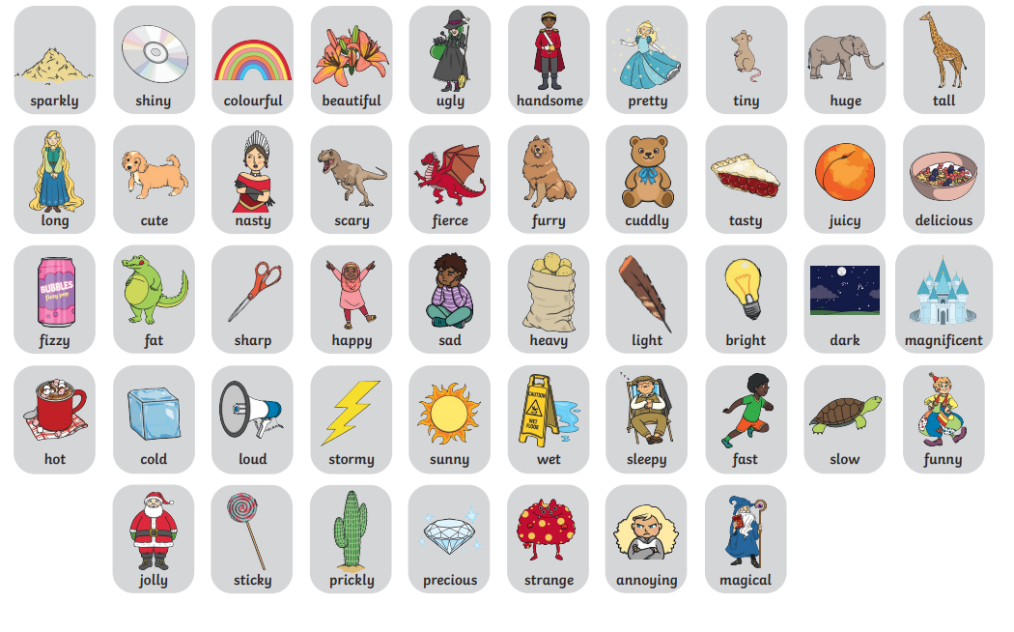

Maths homework
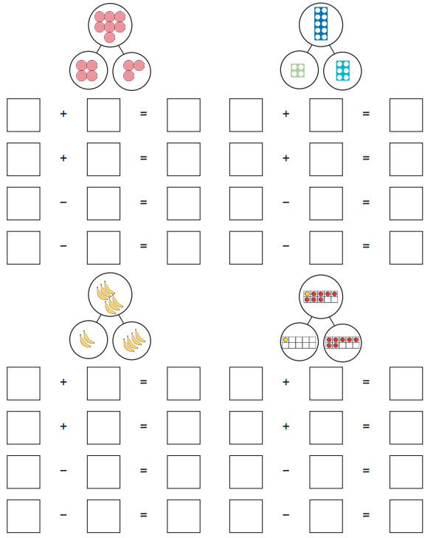
Can you solve the following fact families using addition and subtraction:

