Homework 5th December- due 13th December.
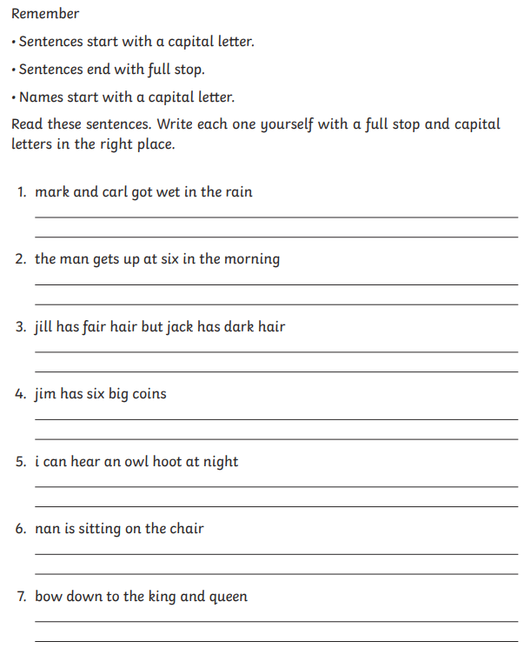
English Homework – Correct the punctuation.

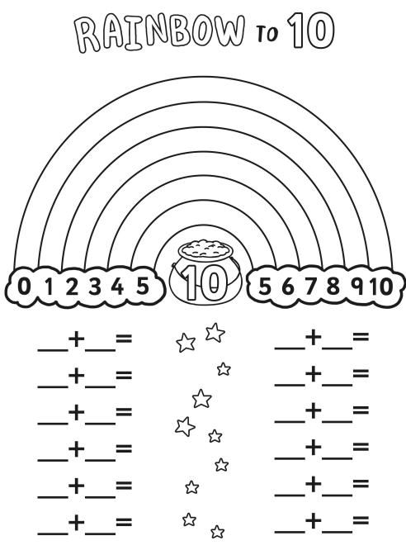
Maths homework- number bonds to 10.

