Year 1 homework – 29/11/24
Due back – 5/12/24
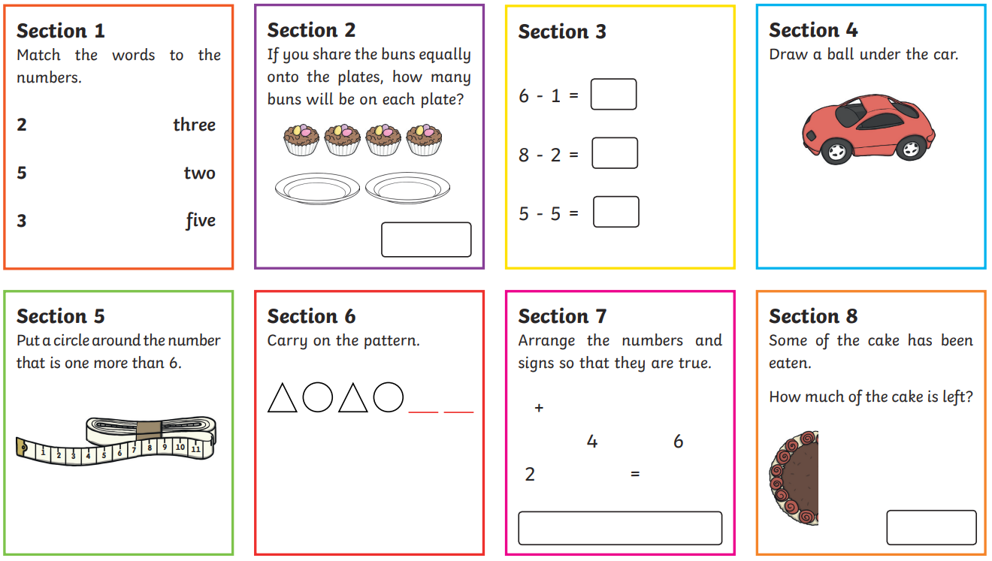
Maths

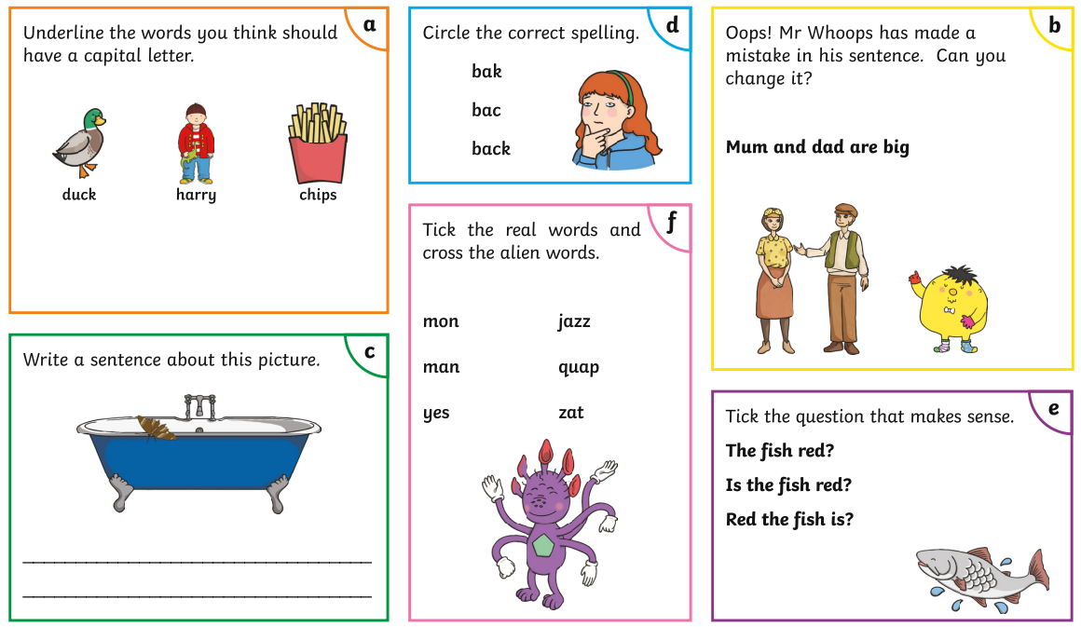
English

