Year 1 Homework
Date given: 22/11/24
Date returned: 27/11/24
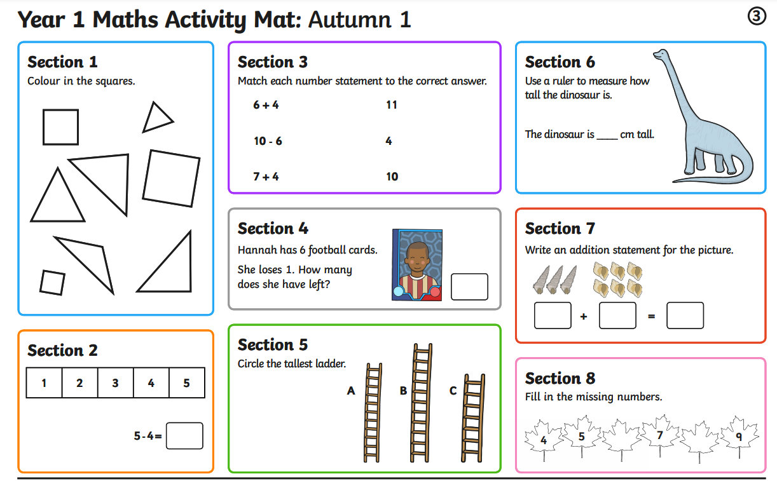
Maths Homework:

Year 1 English Homework
We have been reading Hansel and Gretal this week, by James Marshall.
Please re-write/retell the story with a clear beginning, middle and end.
Here is an online version of the story:
https://www.youtube.com/watch?v=xcWHG2yNX7g
This needs to be written out in your green homework book.

