Year 1 Homework – 26/09/25

English

Maths

This week we have looked at verbs. Choose the correct verb and write it in the space:

- The dog _______________________ the cat.

read or chased

- The bird ______________________ away.

flew or drove

- I _____________________________ a movie.

listened or watched

- Jenny ______________________ a book.

ate or read
Can you do your number bonds to 10?
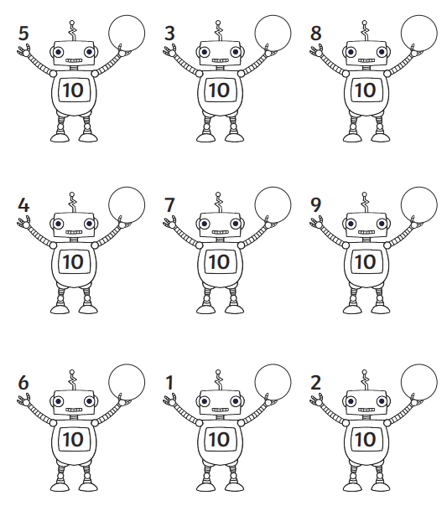

Please practice these common exception words (tricky words).

the my of

Spelling words

