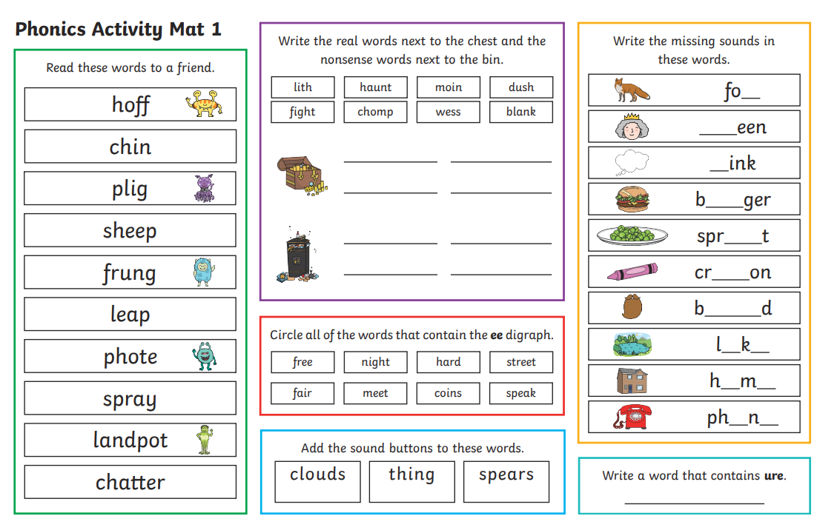
English homework – please practice your phonics sounds alongside this.

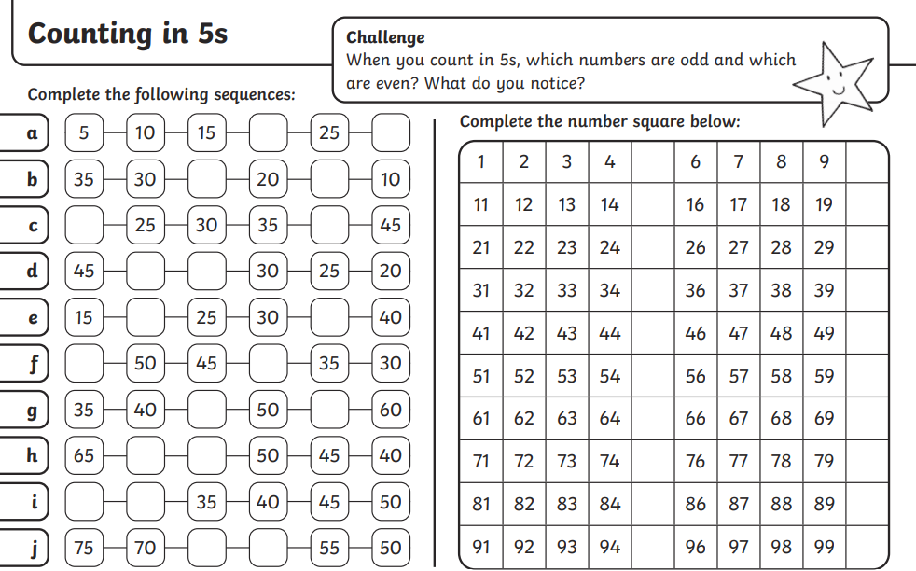
Maths homework- counting in 5s

