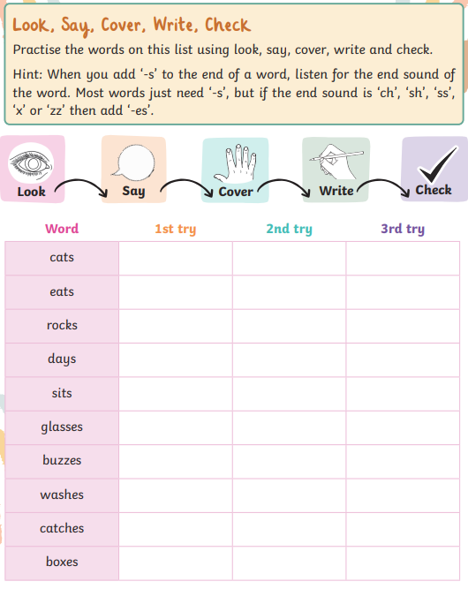
English: Adding ‘s’ or ‘es’ practice.

