English homework
Can you go on a ‘noun’ hunt- this can be anywhere (inside or outside).

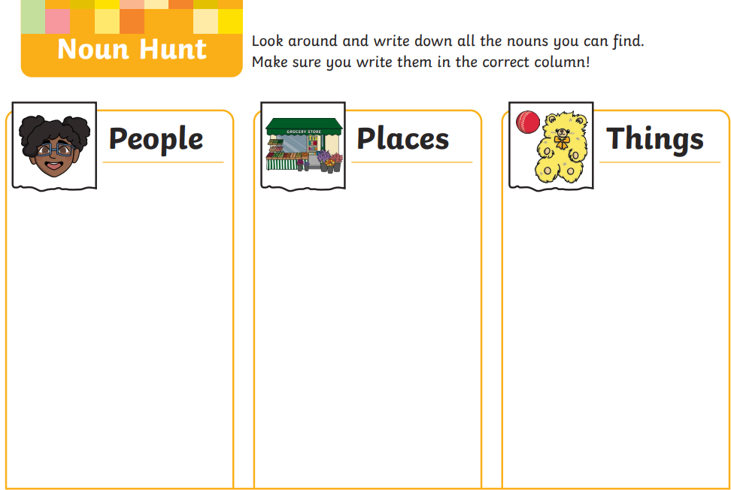

Maths homework
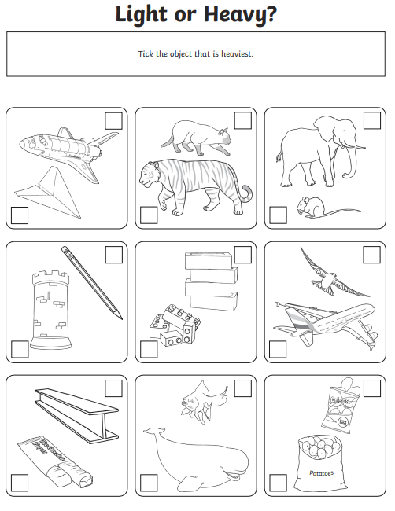
Next week we will be looking at mass and volume. You could also do this with real life objects!

