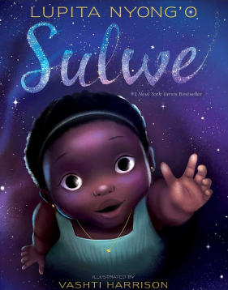
English Homework
For World Book Day, we read the book ‘Sulwe’.
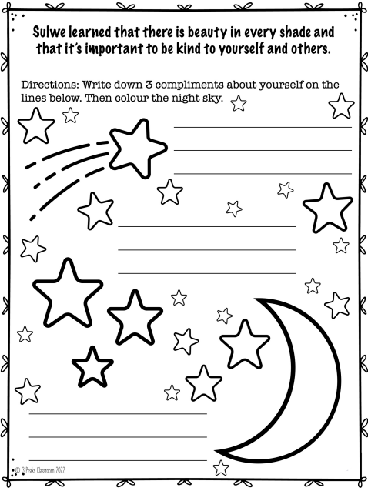
Can you write down 3 compliments about yourself?

Maths Homework


