English Homework – Common Exception words.
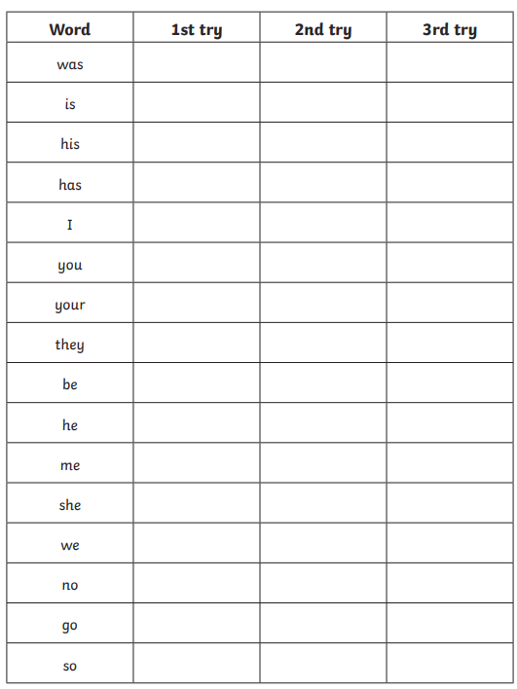
Look at the word, cover, then write it independently.

Maths homework


