English homework
This week we have been looking at the story of ‘King Jack and the Dragon’.
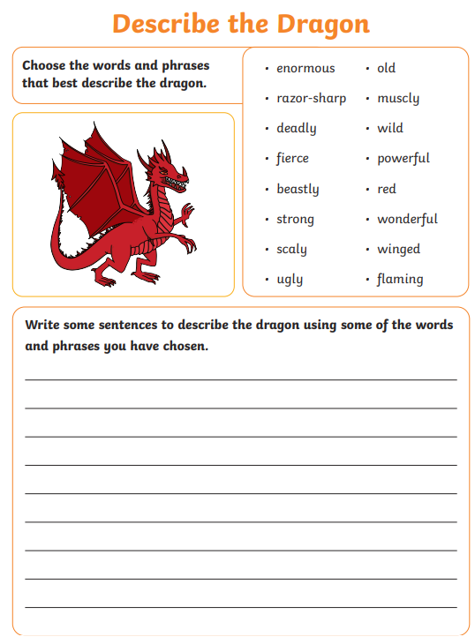

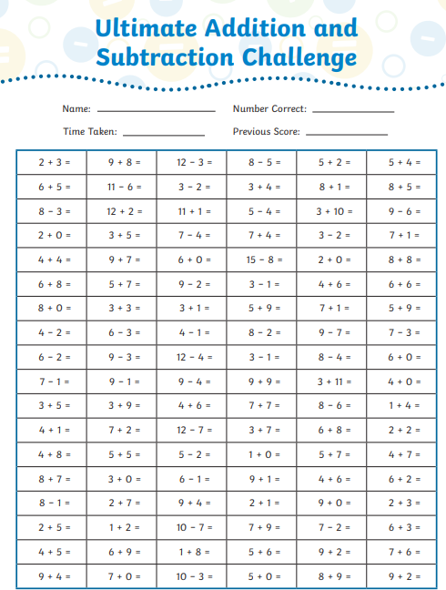
Maths homework

