Maths homework
Next term, we will be looking at place value to 50. Please practice counting to 50 forwards and backwards. You can also practice addition and subtraction.
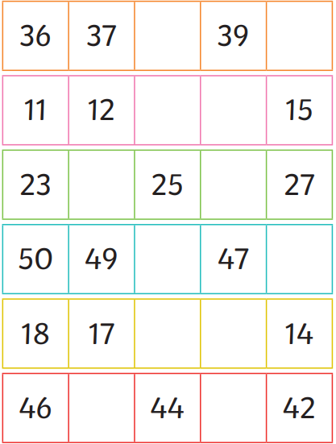
Can you fill in the missing numbers? Make sure numbers are formed correctly.

English homework
Can you practice reading the sounds? All three sounds make the same sound but are spelt differently.
Challenge: Can you write a sentence using some of the sounds?


