- Homework is set every Friday and must be returned the following Tuesday.
Year 3 Homework
Friday 2nd May 2025
- Please use a sharp pencil.

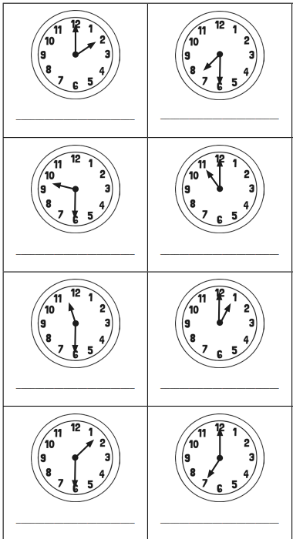
- A ruler should be used when drawing

Why do plants
have roots?

Grammar and Punctuation Homework
Friday 13th September 2024

Punctuate each sentence
- st mary’s is a great school in slough
- what is your name
- my dog can run fast
- the curve library has so many books
- do you like maths
- get out of the way

Science
Friday 13th September 2024
Maths Homework
Friday 13th September 2024

Time
What time is shown on each clock?

