- Homework is set every Friday and must be returned the following Tuesday.
Year 3 Homework
Friday 2nd May 2025
- Please use a sharp pencil.

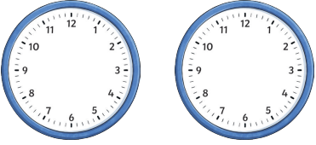
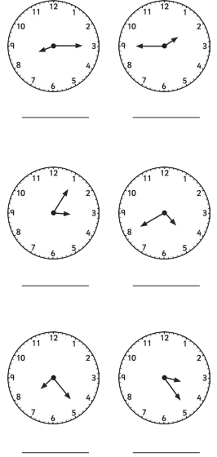
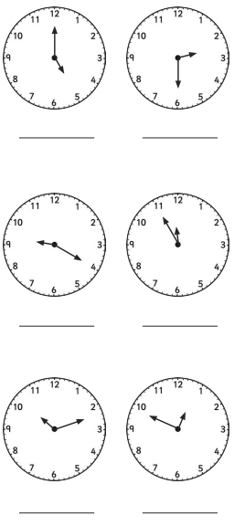
- A ruler should be used when drawing straight lines.

Grammar and Punctuation
What is a subordinate clause? Watch the video and underline the subordinate clauses in the sentences below.
https://www.youtube.com/watch?v=qxTTQ8t7OcY
- Before the party started, Sam blew up the balloons.
- Without money, you cannot buy anything.
- Get your shoes on if you want to go to the park.
- Ask you teacher because I’m unsure of the answer.
- Unless the bus arrives, I will have to start walking.
- While the rain poured down, the puddles got bigger.
- When you have finished your dinner, you may have dessert.

Time
What time is shown on each clock? Answer in books.

Challenge
Draw hands on the clocks to show:
- 20 minutes to 6
- 10 minutes to 10
Science
Friday 13th September 2024

What is the role of
the roots, stem, leaves
and flowers?

Maths Homework
Friday 13th September 2024
English
Friday 13th September 2024

